**JavaScript:**

**Events** event help us to provide the bridge between html and JS code. Whenever user interact with any html tags it generate few events. As a develop we need to handle to generated event and do some specific task base upon our requirements.

JavaScript provided lot of pre defined event. All event start with pre-fix on followed by event name. like

onClick

onDblClick

onMouseOver

onMouseOut

onKeyUp

onKeyDown

onChange

onSubmit

onFocus

onBlur

onload

onUnLoad etc

html code

<input type=”button” value=”Click Here” onClick=”info()”/>

Js code

function info() {

}

**OOPs concept**

object : any real-world entity.

Property or state --🡪 have 🡪

Person

Behaviour -🡪do/does

Bank

Customer

Employee

Car

Bike

Object is a concept

Class : class is a blue print of object or template of object etc.

User defined data types which help to describe the object.

In ES5 JavaScript to implements object concept we were/are using function but from ES6 onward we are using class keyword.

In JavaScript object are divided into 2 types.

1. Pre defined object or built in object
2. User defined object using function keyword or class keyword.

In JavaScript provided two pre defined object hierarchy

BOM : Browser object model

DOM : document object model

Object --🡪property (variables)

Behaviour (function)

Object --------🡪 property

Behaviour

Object ---🡪 property

Behaviour

Object

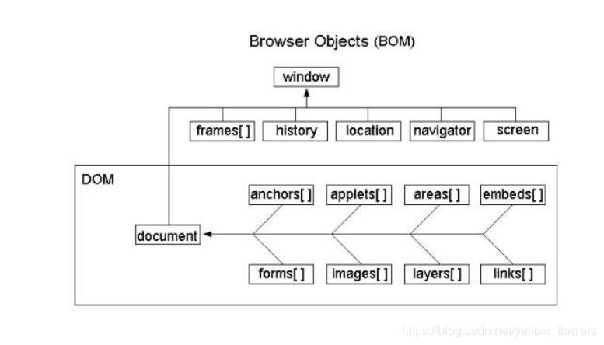

**document.write(“Welcome to JS”)**

document is pre defined object and write is function which help to display output on browser using JS.

window.document.write(“Welcome to JS”);

window.alert(“Welcome”);

**DOM hierarchy or DOM Parser**

JavaScript, Java, Python or other programming provided DOM parser which help to read, write and update html content dynamically.

External JS file

Create separate file with extension **.js**. inside this file you need to write JS code without script tags.

Assignment

Create online calculator

**1st Number Text Field**

**2nd Number Text Field**

**Result Text Field**

**Add Button Sub Button Mul Button Div Button**

Assignment

**Display product details like pid, pname and price in table format. Those data must be added dynamically (row must be dynamic)**

|  |  |  |
| --- | --- | --- |
| **Pid** | **PName** | **Price** |
| 100 | Laptop | 56000 |
| 101 | Computer | 34000 |

**ES6 new Features**

1. From ES6 onward we can declare the variable using var, let const keyword.

Using var we can re-declare same variable once again with same value or different values. But using let we can’t.

Using var we declare global or function scope variable. But using let we declare block scope.

Const keyword is use to declare the constant value. Means we can’t change the value.

1. Different types of function styles.
2. Normal function
3. Expression style function
4. Arrow function : in arrow function function keyword replace by => and curly braces not required if we are planning to write one line statement. Arrow function by default return the value without return keyword.